

**Narrogin Senior High School**

PHYSICAL EDUCATION STUDIES – ATAR

TEST – Functional Anatomy

##### Question/Answer Booklet

Name: _________________________________

### Structure of this paper

|  |  |  |  |
| --- | --- | --- | --- |
| **Section** | **No. of questions available** | **No. of questions to be attempted** | **Marks Available** |
| **A** | **10** | **10** | **/10** |
| **B** | **16** | **16** | **/78** |
|  |  | **Total** | **/88** |

### Instructions to candidates

1. Write your answers in the spaces provided in this Question/Answer Booklet. A blue or black ballpoint or ink pen should be used. Wherever appropriate, fully labelled diagrams, tables and examples should be used to illustrate and support your answers.
2. Section A is to be answered on the question sheet, by crossing out the letter that is your answer.

If you change your answer, circle the incorrect answer and cross out the letter that is your answer.

**SECTION A**

**Multiple Choice**

**Answer all questions. Circle the correct answer.**

1. The Superior Vena Cava carries
   1. Oxygenated blood from the body to the heart
   2. Deoxygenated blood from the body to the heart
   3. Oxygenated blood from the heart to the body
   4. Deoxygenated blood from the heart to the body
2. What relationship do antagonistic pairs of muscles have?
   1. They have nothing to do with each other
   2. One is always the origin or the insertion for the other
   3. When one is contracting the other is relaxing and visa versa
   4. If one is contracting isotonically the other is relaxing isometrically
3. Which of the following muscles is the agonist for extension at the elbow?
   1. Deltoids
   2. Biceps
   3. Quadriceps Group
   4. Triceps
4. All skeletal muscles contain a mixture of fast-twitch and slow-twitch fibres. Through training an athlete:
   1. Can only increase the number of either muscle fibre type
   2. Can increase the size of either muscle fibre type
   3. Can cause all muscle fibres to change from one type to the other
   4. Cannot alter the number or capacity of either muscle fibre types
5. The accurate description of the position of the forearms in the anatomical or reference position is:
   1. Pronated
   2. Rotated
   3. Supinated
   4. Adducted
6. The tibialis anterior muscle contracts to cause which of the following movements at the ankle?
   1. Pronation
   2. Dorsi flexion
   3. Plantar flexion
   4. Rotation
7. From superior to inferior, the 5 regions of the spinal column are:
   1. Cervical, thoracic, sacrum, lumbar, coccyx
   2. Cervical, thoracic, lumbar, sacrum, coccyx
   3. Thoracic, cervical, lumbar, coccyx, sacrum
   4. Cervical, lumbar, thoracic, sacrum, coccyx
8. Where does gaseous exchange take place in the lungs?
   1. Alveoli
   2. Pleura
   3. Diffusion
   4. Bronchus
9. Ligaments are a fibrous, slightly stretchy connective tissue that hold:
   1. Muscle fibres to bone
   2. One bone to another bone
   3. Muscles to other muscles
   4. Bone to cartilage
10. Tendons do what:
    1. Join bone to bone
    2. Join muscles to other muscles
    3. Join ligaments to muscles
    4. Join muscles to bones

**SECTION B**

**Short Answer**

**Answer all questions. Use the lined page at the back of the test paper if room is insufficient, ensuring that answers are clearly labelled.**

**Question 1**

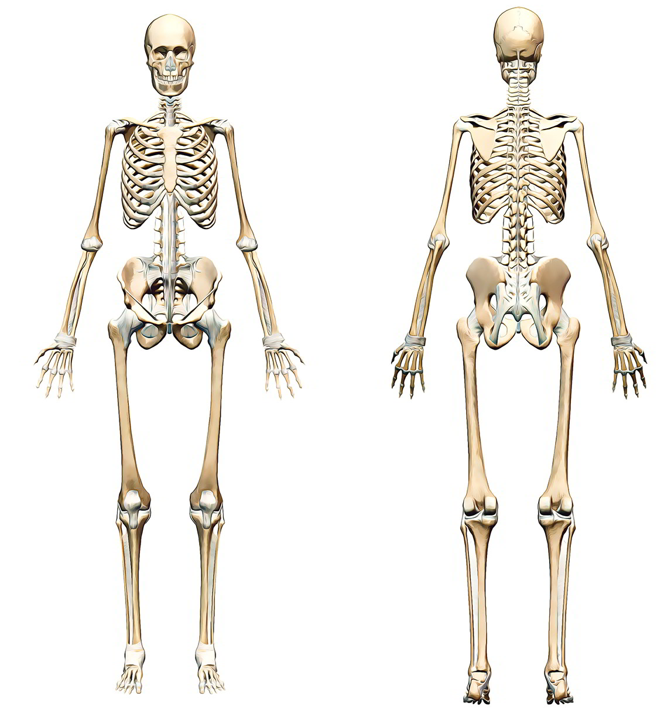

**17 Marks**

Write the name of the bone close to the beginning of the arrowed line

8

7

6

5

4

3

2

1

20

19

18

17

16

15

14

13

12

11

10

9

**Question 2**

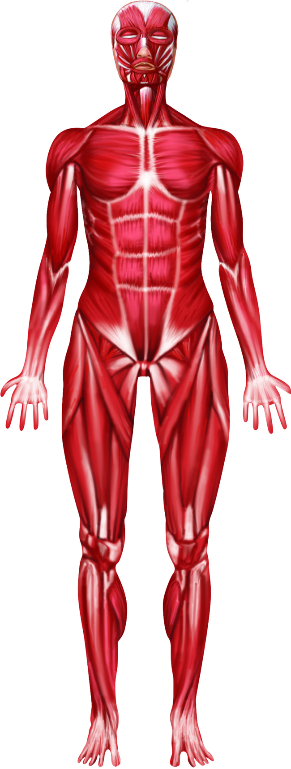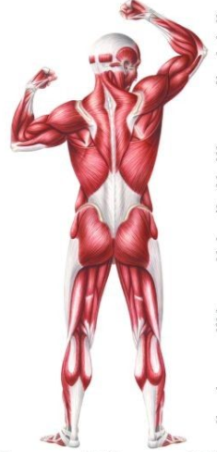

**15 Marks** Write the name of the muscle close to the beginning of the arrowed line

3. **Compare** and **contrast** the structure and function of veins and arteries. (4 marks)

_________________________________________________________________________________________________________________________________________________________________________________________________________________________________________________________________________________________________________________________________________________________________________________________________

4. With the aid of diagrams, explain how gas exchange occurs at the capillary. (4 marks)

____________________________________________________________________________________________________________________________________________________________________________________________________________________________________________________________________________________________________________________

5. Label the diagram of the heart below. (4 marks)

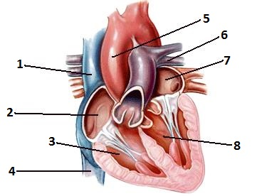

6. List 3 functions of the blood. (3 marks)

__________________________________________________________________________________________________________________________________________________________

_____________________________________________________________________________

7. List the 4 primary components of blood. (2 marks)

_________________________ _______________________

_________________________ _______________________

8. Draw two (2) labelled diagrams that explain the mechanics of breathing. (6 marks)

9. Describe the mechanics of inspiration and expiration. (4 marks)

_______________________________________________________________________________________________________________________________________________________________________________________________________________________________________

_____________________________________________________________________________

10. Define with an example two different types of muscle contraction (4 marks)

_______________________________________________________________________________________________________________________________________________________________________________________________________________________________________

11. Explain the difference between systemic and pulmonary circulation (2 marks)

_______________________________________________________________________________________________________________________________________________________________________________________________________________________________________

12. The diagram below breaks down the movements involved in kicking a soccer ball. (5 marks- 1, 1, 1, 2)

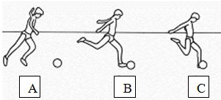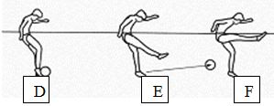

1. What movement occurs at the knee joint when a football player strikes the ball (stages D, E, F, in the diagram above)?

_____________________________________________________________________________

1. Which group of muscles is the prime mover/agonist for this action?

_____________________________________________________________________________

1. Which group of muscles is the antagonist for this action?

_____________________________________________________________________________

1. These 2 groups of muscles also produce movement at the hip joint. State the movement that each group produces at the hip.

__________________________________________________________________________________________________________________________________________________________

13. Total lung capacity is the sum of what capacity and what volume? (1 mark)

__________________________________________________________________________________________________________________________________________________________

14. List 4 joints where circumduction is possible. (2 marks)

______________________ _____________________

______________________ _____________________

15. What are the performance differences between fast and slow twitch muscle fibres? (3 marks)

_______________________________________________________________________________________________________________________________________________________________________________________________________________________________________

16. What is the difference between: (2 marks)

a). Origin of the muscle __________________________________________________________

b). Insertion of the muscle ________________________________________________________

**END OF SECTION B**

ATAR PHYSICAL EDUCATION STUDIES

**Student Name**

**Multiple choice answer sheet.**

For each question, put a cross through the letter which indicates your answer. If you make a mistake, clearly indicate your answer by writing it next to the appropriate question number.

|  |  |  |  |  |
| --- | --- | --- | --- | --- |
| **1** | **A** | **B** | **C** | **D** |
| **2** | **A** | **B** | **C** | **D** |
| **3** | **A** | **B** | **C** | **D** |
| **4** | **A** | **B** | **C** | **D** |
| **5** | **A** | **B** | **C** | **D** |
| **6** | **A** | **B** | **C** | **D** |
| **7** | **A** | **B** | **C** | **D** |
| **8** | **A** | **B** | **C** | **D** |
| **9** | **A** | **B** | **C** | **D** |
| **10** | **A** | **B** | **C** | **D** |

**Marking Key**

**SECTION A**

1. a **b** c d

2. a b **c** **d**

3. a b c **d**

4. a **b** c d

5. a b **c** d

6. a **b** c d

7. a **b** c d

8. **a** b c d

9. a **b** c d

10. a **b** c d

**SECTION B**

1. Label the bones on the diagram below. (17 marks)

Insert key according to your diagram

2. Label the muscles on the diagram below. (15 marks)

Insert key according to your diagram

3. Compare and contrast the structure and function of veins and arteries. (4 marks)

|  |  |  |
| --- | --- | --- |
|  | 1 mark | 2 marks |
| Compare | Both transport blood around the body **or** both are tubes containing smooth muscle | Both transport blood around the body **and** both are tubes containing smooth muscle |
| Contrast | Arteries take oxygenated blood away from the heart whereas veins return deoxygenated blood to the heart **or** arteries have a thicker layer of smooth muscle tissue whereas veins have valves to prevent backflow of blood | Arteries take oxygenated blood away from the heart whereas veins return deoxygenated blood to the heart **and** arteries have a thicker layer of smooth muscle tissue whereas veins have valves to prevent backflow of blood |

4. With the aid of diagrams, explain how gas exchange occurs at the capillary or alveoli. 4 Marks

|  |  |
| --- | --- |
| Description | Marks |
| Draws a diagram with O2 in the alveoli | 1 |
| Draws a second diagram with O2 having moved over | 1 |
| Identifies that the walls of the capillary are very thin. | 1 |
| Identifies that the capillary/alveoli is the junction between the circulatory system and a muscle cell or the respiratory system and the circulatory | 1 |

5. Label the diagram of the heart below. (4 marks)

1. Superior vena cava
2. R Atrium
3. L Ventricle
4. Inferior vena cava
5. Aorta
6. Pulmonary Artery
7. L Atrium
8. L Ventricle

6 List 3 functions of the blood. (3 marks)

|  |  |
| --- | --- |
|  | 1 mark per acceptable response to a maximum of 3 marks |
| Function | Any of: transport water, oxygen, nutrients to the body; transport wastes away from cells; thermoregulation; fight disease |

7. List the 4 primary components of blood. (2 marks)

|  |  |
| --- | --- |
|  | ½ mark per acceptable response to a maximum of 2 marks |
| Components | Any of: red blood cells; white blood cells; plasma; platelets |

8. Draw 2 labelled diagrams

|  |  |
| --- | --- |
| Description | Marks |
| Diagram labelled Inspiration | 1 |
| Diagram Labelled Expiration | 1 |
| Diaphragm contracts on Inspiration | 1 |
| Diaphragm relaxes on Expiration | 1 |
| High & Low pressures accurate Expiration | 1 |
| High & Low pressures accurate Inspiration | 1 |

9. Describe the mechanics of breathing. (4 marks)

|  |  |  |
| --- | --- | --- |
|  | 1 mark | 2 marks |
| Inspiration | Diaphragm contracts and pulls down **or** intercostal muscles contract to pull the ribcage outwards | Diaphragm contracts and pulls down **and** intercostal muscles contract to pull the ribcage outwards |
| Expiration | Diaphragm relaxes and draws upwards **or** intercostal muscles relax causing the ribcage to draw inwards | Diaphragm relaxes and draws upwards **and** intercostal muscles relax causing the ribcage to draw inwards |

10. Define with example two different types of muscle contraction (4 Marks)

|  |  |
| --- | --- |
| Description | Marks |
| Isotonic- accurate definition | 1 |
| Isotonic – relevant example | 1 |
| Isometric - accurate definition | 1 |
| Isometric – relevant example | 1 |
| Isokinetic - accurate definition | 1 |
| Isokinetic – relevant example | 1 |

11. Explain the difference between systemic and pulmonary circulation (2 Marks)

|  |  |
| --- | --- |
| Description | Marks |
| Systemic- O2 rich side of the circulatory system | 1 |
| Pulmonary- deoxygenated side of the circulatory system | 1 |

10. List, in order, the structures that a molecule of oxygen passes through on its journey from the mouth to a pulmonary capillary? (4 marks)

|  |  |
| --- | --- |
| Structures | ½ mark per structure: pharynx, larynx, trachea, bronchi, bronchiole, alveoli |
| Correct order | 1 mark for the 6 structures in the correct order |

12. The diagram below breaks down the movements involved in kicking a soccer ball. (5 marks)

1. What movement occurs at the knee joint when a football player kicks the ball?

|  |  |
| --- | --- |
|  | 1 mark |
| Movement | Extension |

1. Which group of muscles is the prime mover/agonist for this action?

|  |  |
| --- | --- |
|  | 1 mark |
| Prime mover | Quadriceps group |

1. Which group of muscles is the antagonist for this action?

|  |  |
| --- | --- |
|  | 1 mark |
| Antagonist | Hamstrings group |

1. These 2 groups of muscles also produce movement at the hip joint. State the movement that each group produces at the hip.

|  |  |
| --- | --- |
|  | 1 mark |
| Quadriceps group | Flexion |
| Hamstrings group | Extension |

13. Total lung capacity is the sum of what capacity and what volume?

|  |  |
| --- | --- |
| Description | Marks |
| Vital capacity + residual volume | 1 |

12. Explain the difference between adduction and abduction? (1 mark)

|  |  |
| --- | --- |
|  | 1 mark |
| Difference | Abduction – limb taken away from the midline of the body **and** adduction – limb brought towards the midline of the body |

14. List 4 joints where circumduction is possible. (2 marks)

|  |  |
| --- | --- |
|  | ½ mark per acceptable response to a maximum of 2 marks |
| Joints | Head/neck, shoulder, hip, phalange/metacarpal, phalange/metatarsal, wrist |

15. What are the performance differences between fast and slow twitch muscle fibres? (3 marks)

|  |  |
| --- | --- |
|  | 1 mark per acceptable response to a maximum of 3 marks |
| Performance difference | Fast twitch – contract more quickly; fast twitch – contract with greater force; slow twitch – fatigue resistant |

16. What is the difference between the origin and the insertion of a muscle (2 Marks)

|  |  |
| --- | --- |
| Description | Marks |
| Origin attaches to the bone that doesn’t move | 1 |
| Insertion attaches to the bone that does move | 1 |

15. What colour are slow twitch muscle fibres? Explain why? (2 marks)

|  |  |  |
| --- | --- | --- |
|  | 1 mark | 2 marks |
| Colour & why | States that slow twitch muscle fibres are red **or** because they have a plentiful blood supply | States that slow twitch muscle fibres are red **and** because they have a plentiful blood supply |

**Convert mark out of 60 to a mark out of 5 for Units 2A and 2B.**